DAY9 SESSION ASSIGNMENTS (Theory)

1. Draw a Use Case Diagram for an online Library Management System
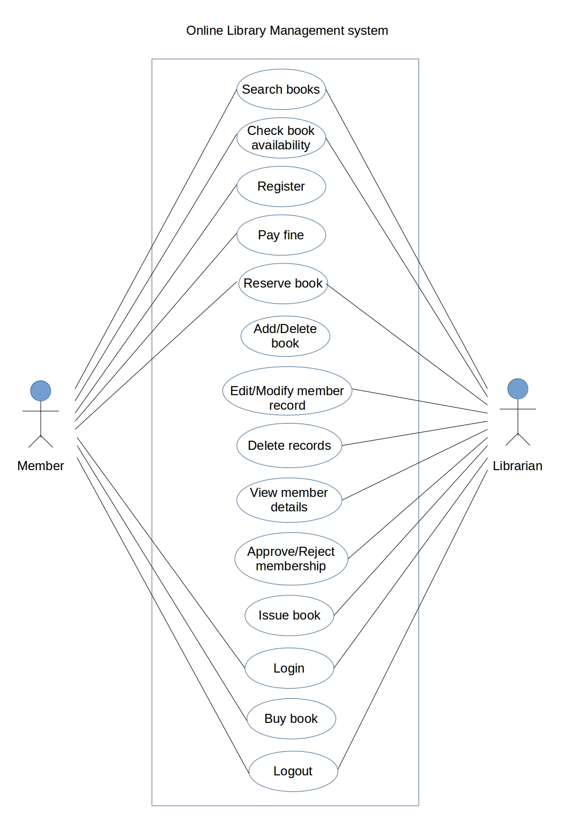

2. List down the best practices from Agile/Scrum methodology

- Dynamic and flexible
- Adaptable to changes and responding to changes
- Collaborative environment between the people in the teams
- Priorities are maintained by product owner
- All the processes and practices are facilitated by Scrum master
- Sprint planning meeting to create sprint backlog
- Planning poker is used to estimate tasks during sprint planning
- Mutual commitment to sprint backlog between product owner and team
- Daily 15 min stand-up meetings to discuss what was done and what is to be done
- Self-organizing team
- Burn down and Burn ups chart to monitor performance
- Sprint review meeting to present completed work
- Sprint retrospective to learn from previous sprint
- Release planning to release product increments
- User stories are created from the requirements
- Open work space is provided for the team
- Simplicity in design and the phases
- Set a sustainable pace
- The project velocity is measured
- Move people around and make them colocated to a single place so that they can communicate face to face and communication gap can be reduced
- The customer is always involved in regular intervals of time
- Continuous integration of code allows to keep the code up to date and respond to changes
- Outcome will be the deliverable at each sprint
- Refactor whenever and wherever needed
- All sessions begin by writing programming adaptive tests that are preceded by unit tests.i.e Test driven development
- Acceptance tests are run often where the client is invloved

3. Collaboration
a. How does collaboration help agile development?
Agile methodologies emphasize the value of collaboration. Agile forces people from different backgrounds to work together on the Agile team, here the teams are self organized. The people in the team can be colocated and bring to a common place so that their communication gap can be reduced and they will get fast responses even if an issue may arise.

- The collaboration allows the teams to interact successfully and share the ideas among them
- Face to face communication increases productivity as the communication gap can be reduced
- The team delivers the products early and successfully and this would satisfy the customers
- The team welcomes changing requirements
- There would be regular meetings between the dev team and the clients
- The team regularly tunes and adjusts its behaviour
Each of the member will be able to find the negative aspects of the project which makes it easy to reduce the errors and the risks that are about to occur in future

b. What if the team is distributed and can you achieve the same productivity?

No , it is not possible to achieve the same productivity if the team is distributed.

- If the team is distributed, trouble lies ahead. The best way to discover issues and blockers is through face-to-face communication.
- If the team members are not familiar with each other they will not be aware about each other’s skills.
- There are chances for miscommunication
- It will not be easy to handle the arguments and suggestions that would arise from the different team mates which will affect the productivity
c. What would you do to achieve the productivity for a distributed team?

When possible, try to get people in the same room for crucial parts of a project. Otherwise,maintain over communication with remote teammates and keep them in the loop.

4. What is Sprint Zero in Agile? Describe the activities that are done in Sprint Zero.

Sprint Zero is is the initialization step in an agile project which is also called as Iteration Zero. It consists of certain activities that will make the team ready for the sprint 1. It is also known as a project before a project phase because at the beginnig of a project there should be a detailed analysis about how the project has to be done. Following activities are included in the sprint zero :-

- Active stakeholder participation
- Obtain funding and support
- Start building the team
- Initial requirements envisioning
- Initial architecture envisioning
- Set up environment
But the velocity of Sprint Zero may be very low compared to that of other sprints.

